**Frontend Development with React.js**

**Project Documentation**

**INTRODUCTION:**

**Project Title**: FitFlex: Your Personal Fitness Companion

**Team Members**:

**Uma Maheswari N- Frontend Developer (React.js) & Team Leader**

**Swathi L**

**Vanitha N**

**Shalini K**

**Project Overview**:

FitFlex is a game-changing fitness app that makes workouts easy and personalized. With a user-friendly interface, smart search, and a wide range of exercises for all levels, it helps you reach your fitness goals effortlessly.

Welcome to FitFlex – Your Ultimate Fitness Companion!

Step into the future of fitness with **FitFlex**, a cutting-edge app designed to transform the way you engage with workouts. Whether you’re just starting your fitness journey or are a seasoned athlete, FitFlex is built to cater to all levels, helping you achieve your wellness goals effortlessly.

🌟 **Smart, Intuitive, and Dynamic**

FitFlex redefines how you explore exercises with its sleek, user-friendly interface and powerful features. Navigate seamlessly through a vast library of workouts, discover personalized routines, and access expert-recommended exercises tailored to your needs. Our **dynamic search feature** ensures you always find the right workout, whether it’s strength training, cardio, yoga, or HIIT.

🏋️ **A Fitness Hub for Everyone**

More than just an app, FitFlex fosters a thriving community of fitness enthusiasts and professionals. Share your progress, connect with like-minded individuals, and gain insights from fitness experts. Our vision is to create an interactive platform that not only provides high-quality workout content but also inspires and motivates you to stay consistent.

🚀 **Innovation Meets Fitness Excellence**

At FitFlex, we blend innovation with time-tested fitness principles to deliver an immersive workout experience. Every tap brings you closer to a world of diverse exercises, expert guidance, and new fitness perspectives, ensuring you stay engaged and inspired on your wellness journey.

💪 **Your Partner in Achieving a Healthier Lifestyle**

Trust **FitFlex** to be your dedicated fitness companion, guiding you towards an active, balanced, and healthier life. Whether your goal is muscle building, weight loss, endurance training, or overall well-being, FitFlex is here to support and elevate your fitness journey.

Join FitFlex today – where every workout is a step toward a stronger, healthier you!

**Imagine a Fitness Journey Like Never Before – Welcome to FitFlex!**

You wake up feeling motivated to work out, but you’re unsure where to start. Scrolling through endless fitness routines feels overwhelming, and finding the right exercises for your goals seems like a challenge. What if there was an app that understood your needs, guided you effortlessly, and kept you motivated every step of the way?

🌟 **Enter FitFlex – Your Personalized Fitness Companion!**

Whether you’re a beginner looking to build a solid foundation or a fitness pro seeking fresh challenges, **FitFlex** adapts to your journey. With an intuitive interface, a dynamic search for exercises, and tailored workout recommendations, achieving your wellness goals has never been easier.

No more confusion. No more one-size-fits-all workouts. Just the right exercises, expert guidance, and a supportive community—all in one place.

**Project Goals and Objectives**:

The overarching aim of FitFlex is to offer an accessible platform tailored for individuals passionate about fitness, exercise, and holistic well-being. Our key objectives are as follows:

* User-Friendly Experience: Develop an intuitive interface that facilitates easy navigation, enabling users to effortlessly discover, save, and share their preferred workout routines.
* Comprehensive Exercise Management: Provide robust features for organizing and managing exercise routines, incorporating advanced search options for a personalized fitness experience.
* Technology Stack: Harness contemporary web development technologies, with a focus on React.js, to ensure an efficient and enjoyable user experience.

**Features of FitFlex**:

* Exercises from Fitness API:

Access a diverse array of exercises from reputable fitness APIs, covering a broad spectrum of workout categories and catering to various fitness goals.

* Visual Exercise Exploration:

Engage with workout routines through curated image galleries, allowing users to explore different exercise categories and discover new fitness challenges visually.

* Intuitive and User-Friendly Design:

Navigate the app seamlessly with a clean, modern interface designed for optimal user experience and clear exercise selection.

* Advanced Search Feature:

Easily find specific exercises or workout plans through a powerful search feature, enhancing the app's usability for users with varied fitness preferences.

**Technical Architecture**:

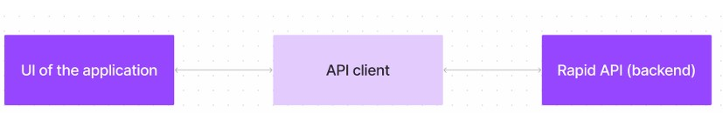

FitFlex prioritizes a user-centric approach from the ground up. The engaging user interface (UI), likely built with a framework like React Native, keeps interaction smooth and intuitive. An API client specifically designed for FitFlex communicates with the backend, but with a twist: it leverages Rapid API. This platform grants access to various external APIs, allowing FitFlex to potentially integrate features like fitness trackers, nutrition data, or workout tracking functionalities without building everything from scratch. This approach ensures a feature-rich experience while focusing development efforts on the core FitFlex functionalities.

**Setup Instructions:**

**To build a frontend application using React.js, ensure you have the following:**

**Node.js and npm – Required to run JavaScript outside the browser.**

* **Download:** [**Node.js**](https://nodejs.org/en/download/)
* **Installation Guide:** [**Package Manager**](https://nodejs.org/en/download/package-manager/)

**React.js – A popular JavaScript library for building user interfaces. Create a new React app**

* npx create vite@latest
* cd my-react-app
* npm start
* Open [http://localhost:3000](http://localhost:3000/) in your browser to see the app
* **Basic Web Technologies** – Understanding of **HTML, CSS, and JavaScript** is essential.
* **Version Control (Git & GitHub)** – Helps track changes and collaborate.
* Download Git: [Git](https://git-scm.com/downloads)
* **Code Editor/IDE** – Choose a development environment:
* [VS Code](https://code.visualstudio.com/download)
* [Sublime Text](https://www.sublimetext.com/download) • [WebStorm](https://www.jetbrains.com/webstorm/download)

* **Setting Up the Project from Google Drive**
* **Download the Code**

Get the project from this Drive link: [Project Link](https://drive.google.com/drive/folders/14f9eBQ5W7VrLdPhP2W6PzOU_HCy8UMex?usp=sharing)

* **Install Dependencies**
* Open a terminal and navigate to the project folder:
* cd fitness-app-react

* **Install required libraries:**
* npm install

* **Run the Application** Start the development server:
* npm start
* Open [http://localhost:3000](http://localhost:3000/) in your browser. If you see the homepage, the setup is successful!

**Project structure:**

In this project, we’ve split the files into 3 major folders, Components, Pages and Styles. In the pages folder, we store the files that acts as pages at different URLs in the application. The components folder stores all the files, that returns the small components in the application. All the styling css files will be stored in the styles folder**.**

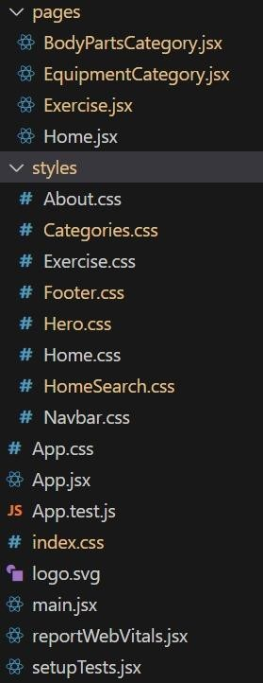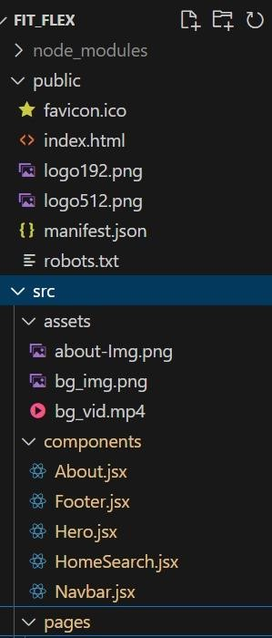

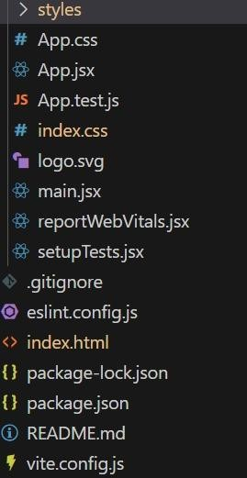

**Component Documentation:**

**Key Components**

* Navbar: Provides navigation across different pages.
* Hero: Displays the homepage introduction.
* Categories: Lists exercise categories.
* Exercise List: Displays exercises under a category.
* Exercise Details: Shows instructions, related videos, and details of a selected exercise.
* Subscription Form: Allows users to subscribe to newsletters.
* Footer: Contains additional links and contact information. Reusable Components
* Button: Customizable button component.
* Card: Displays exercises in a structured format. • Loader: Shows loading animation when fetching data.

**State Management:**

**Global State**

* Managed using React Context or Redux for storing user preferences and fetched API data**.**

**Local State**

* Managed with useState for handling component-specific states such as form inputs and modal visibility**.**

**User Interface: FitFlex features a modern UI with:**

* Intuitive navigation
* Responsive design
* Interactive exercise search and filters

**Styling:**

**CSS Frameworks/Libraries**

* Tailwind CSS: Used for consistent styling.
* React Icons: Used for scalable icons. Theming
* Supports dark/light mode with custom CSS variables**.**

**Project Execution:**

* After completing the code, run the react application by using the command “npm
* start” or “npm run dev” if you are using vite.js
* Here are some of the screenshots of the application.
* **Hero component**
* this section would showcase trending workouts or fitness challenges to grab

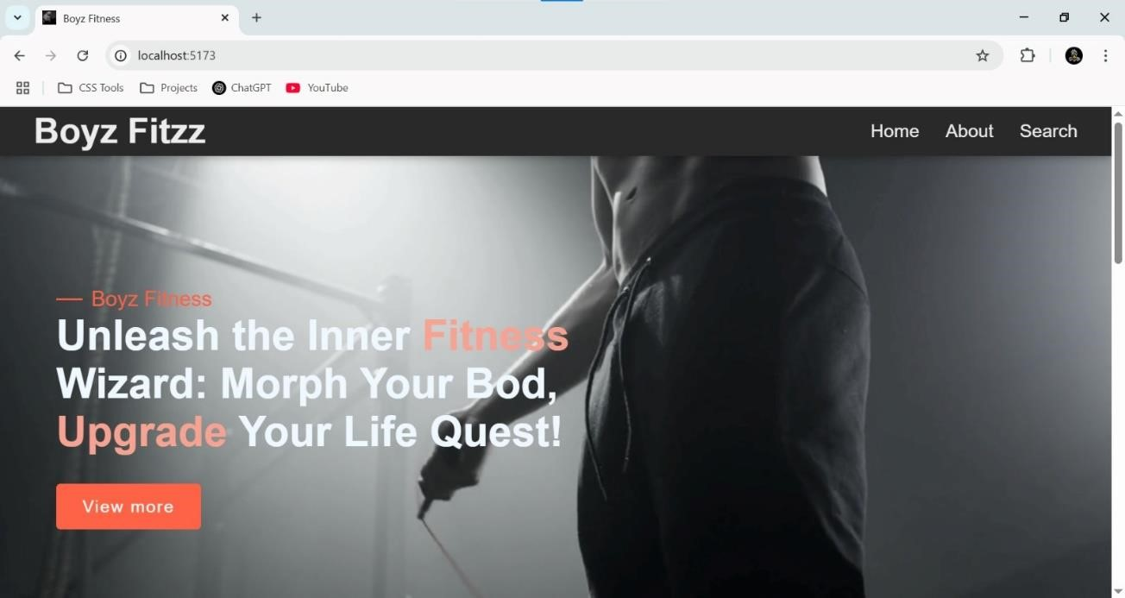

**About**

FitFlex isn't just another fitness app. We're meticulously designed to transform your workout experience, no matter your fitness background or goals

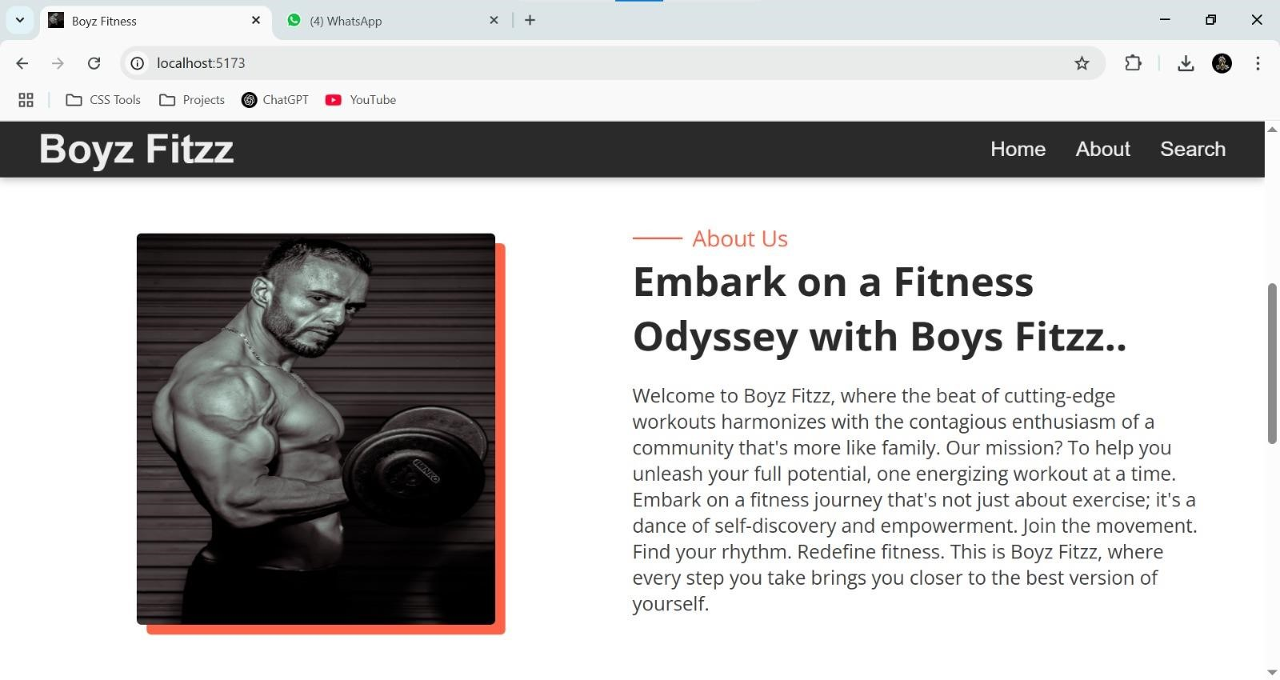

**Search**

Boyz Fitzz makes finding your perfect workout effortless. Our prominent search bar empowers you to explore exercises by keyword, targeted muscle group, fitness level, equipment needs, or any other relevant criteria you have in mind. Simply type in your search term and let FitFlex guide you to the ideal workout for your goals

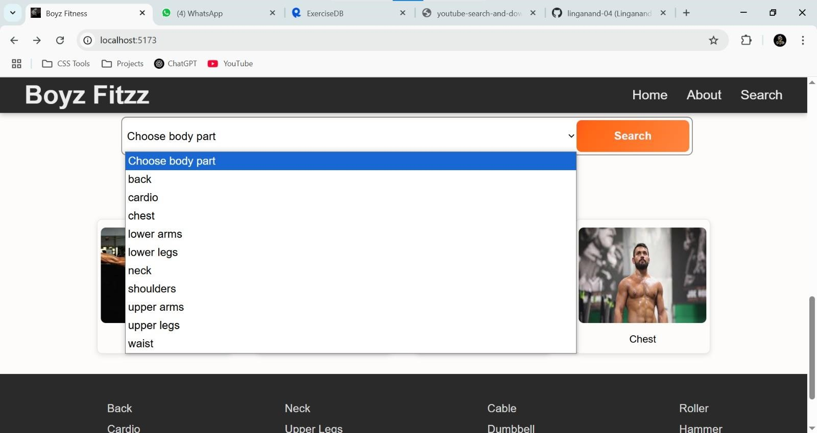

**Category page**

FitFlex would offer a dedicated section for browsing various workout categories. This could be a grid layout with tiles showcasing different exercise types (e.g., cardio, strength training, yoga) with icons or short descriptions for easy identification

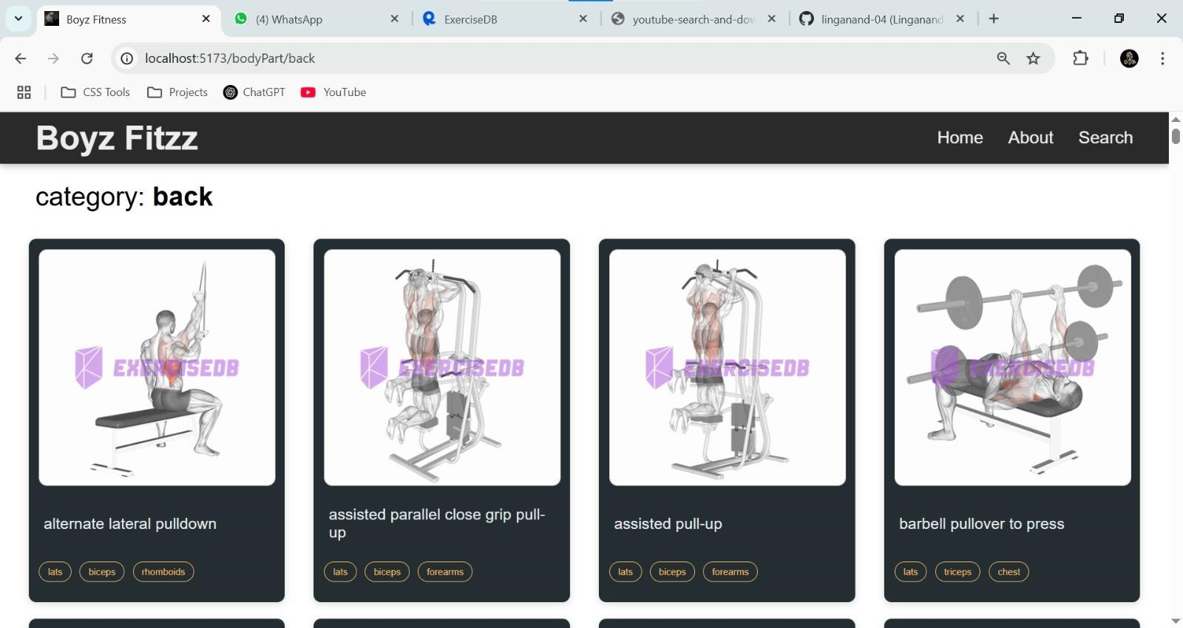

**Exercise page:**

This is where the magic happens! Each exercise page on FitFlex provides acomprehensive overview of the chosen workout. Expect clear and conciseinstructions, accompanied by high-quality visuals like photos or videos demonstrating proper form. Additional details like targeted muscle groups, difficulty level, and equipment requirements (if any) will ensure you have all the information needed for a safe and effective workout.

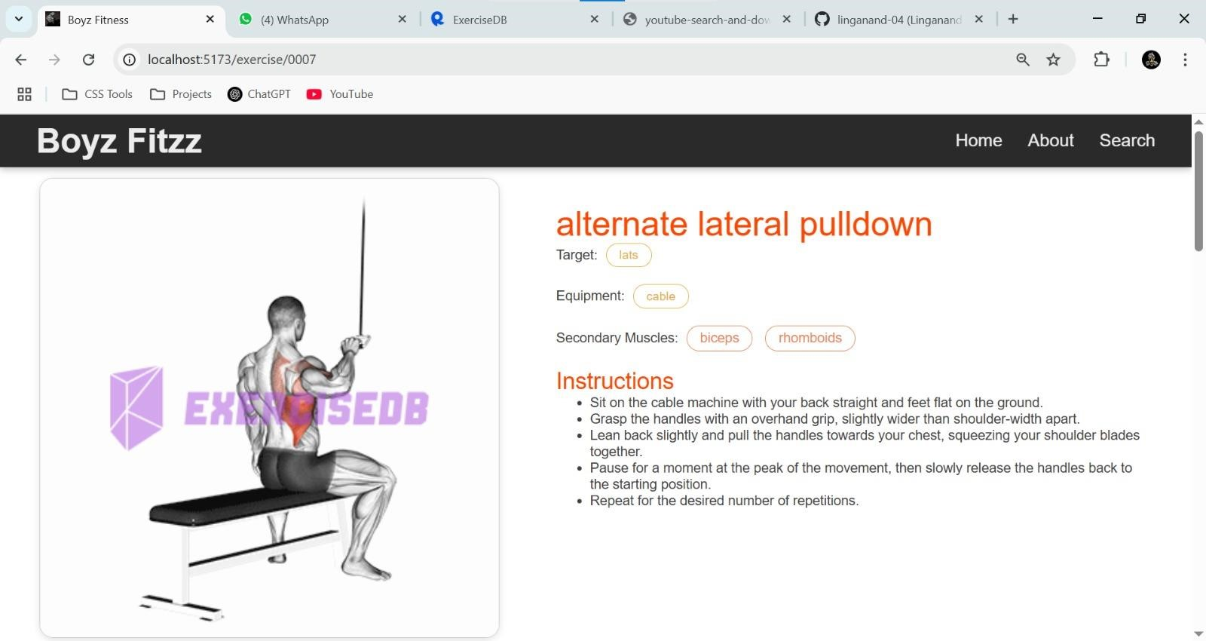

Related Youtube videos:

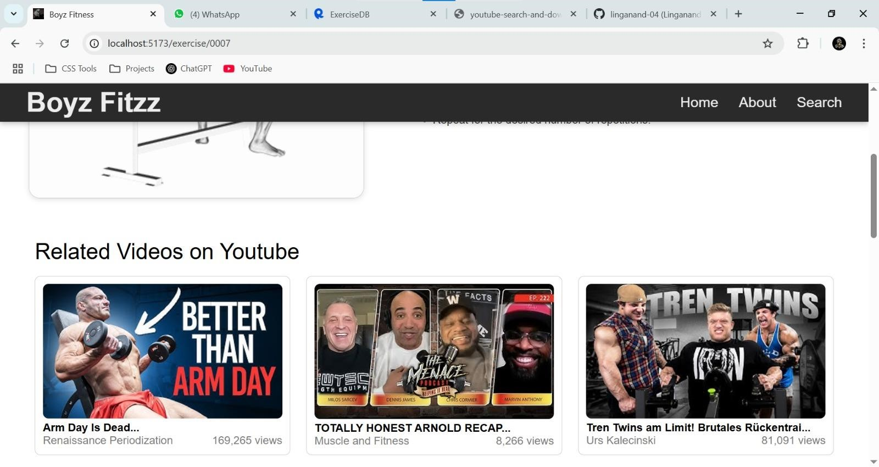

**Testing:**

**Testing Strategy**

* Unit Testing: Performed using Jest and React Testing Library.
* Integration Testing: Ensuring API calls work correctly.
* End-to-End Testing: Conducted with Cypress. Code Coverage • Coverage is monitored using Jest.

**Known Issues:**

* API rate limits may affect data fetching. • Some exercises may not have related YouTube videos.

**Future Enhancements:**

* Add user authentication for personalized workout tracking.
* Implement AI-powered workout recommendations.
* Improve animations and transitions.

**Project Demo:**

[**https://drive.google.com/file/d/1ynOb6sIhQckfHHuW58AroIy4xwIKO**](https://drive.google.com/file/d/1ynOb6sIhQckfHHuW58AroIy4xwIKOMxr/view?usp=drive_link)

[**Mxr/view?usp=drive_link**](https://drive.google.com/file/d/1ynOb6sIhQckfHHuW58AroIy4xwIKOMxr/view?usp=drive_link)

THANK YOU